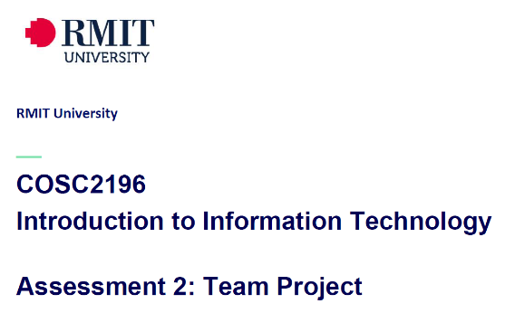 **A2, Group #4 MEETING**

**Venue:** Online via MS Teams

**Date: 11-4-21**

**Agenda**

**Meeting Opened: (time)**

**Attendance: Paul Eccarius, Rebecca Watson, Martin Lee, Nour Zeroual, Jarrad Hofman-Agar**

**Apologies:**

**Meeting Chair:**

**Minutes Secretary:**

1. **Minutes from previous Meeting -**

* **Actions arising as per Action Register**

|  |  |  |  |  |  |
| --- | --- | --- | --- | --- | --- |
| **Meeting Date** | **Action** | **Who to action** | **Completed Y/N** | **Update at meeting** | **Further action** |
| 31/3/21 | Team Name! | Everyone | Yes | 11/4/21 | Team_Name_404 is the winner. |
| 31/3/21 | Profile & IT Jobs Collation | Rebecca | Draft Complete | 11/4/21 | Put profile photos in report (to match website) |
| 31/3/21 | Github & Archiving | Paul | In hand, ongoing | 11/4/21 | Framework is there, Paul to finalise content as it is completed |
| 31/3/21 | Interview Questions & Appointment | Nour | Need update- ask Nour how she is going with it | 11/4/21 | Interview to be done as a group within the next week and a half. Question template on Canvas. |
| 31/3/21 | Industry Information – Revist on 6/4/21 | Jarrad | Ongoing | 11/4/21 | Jarrad to work on when his new computer arrives, will let the team know if he needs assistance. Using information from our ideal jobs section. |
| 31/3/21 | IT Technologies Report:    Martin: Cybersecurity  Rebecca: Cloud Services  Nour: Machine Learning  Paul: Raspberry Pi etc. | Team | **Martin**: should be complete by tomorrow and uploaded to teams.  **Paul**: to be completed.  **Bec**: Report is done by currently a few too many words.  **Nour**: need update | 11/4/21 | Reports to be completed by end of this week and uploaded to MS Teams & Github/website. |
| 31/3/21 | Project Ideas | Team | Ongoing - See discussion in minutes. | 11/4/21 | Team members are going to wait to see their feedback and marks from A1 to decide on final project – decision to be made at next meeting. |

1. **Correspondence:**

Umera advised via email 9-4-21 that Anthony Middleton has been removed from the group.

1. **Industry Data**
2. **Tools**
3. **IT Work**
4. **IT Technologies**
5. **Project Ideas**
6. **Additional points for discussion?**

* Bibliography for overall document.

**Next meeting date:**

**Meeting closed: (time)**

**Actions Register**

|  |  |  |  |  |  |
| --- | --- | --- | --- | --- | --- |
| Meeting Date | Action | Who to action | Completed Y/N | Update at meeting | Further action |
|  |  |  |  |  |  |